#CTS NURTURE 4.0_ JAVA FSE

# WEEK 3

# CONFIGURING A BASIC SPRING APPLICATION:

STUDENT_ MAVEN PROJECT:

# Class: Student.java(inside model package)

package com.ctsnurture.model;

public class Student {

private String id;

private String name;

private String course;

public Student(String id, String name, String course) {

this.id = id;

this.name = name;

this.course = course;

}

public void showDetails() {

System.out.println("ID: " + id + ", Name: " + name + ", Course: " + course);

}

}

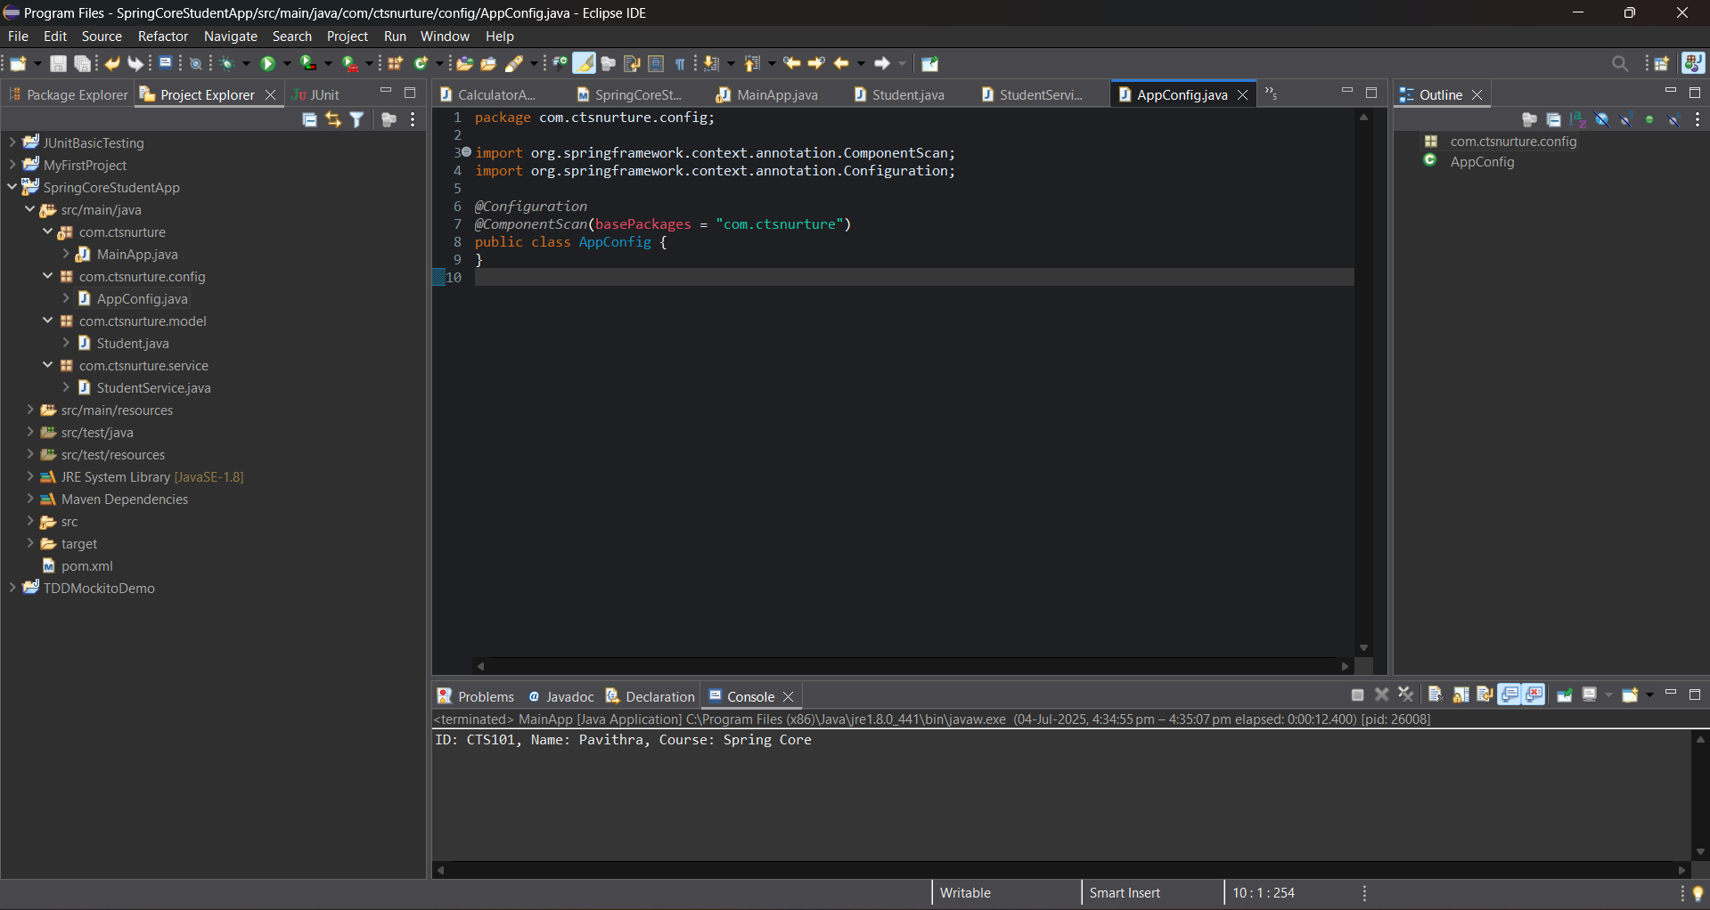

# Class: StudentService.java (inside service package)

package com.ctsnurture.service;

import com.ctsnurture.model.Student;

import org.springframework.stereotype.Component;

@Component

public class StudentService {

public Student registerStudent(String id, String name, String course) {

return new Student(id, name, course);

}

}

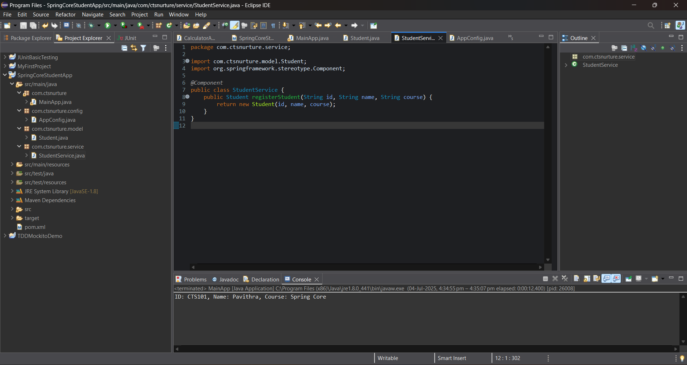

# Class: AppConfig.java (inside config package)

package com.ctsnurture.config;

import org.springframework.context.annotation.ComponentScan;

import org.springframework.context.annotation.Configuration;

@Configuration

@ComponentScan(basePackages = "com.ctsnurture")

public class AppConfig {

}

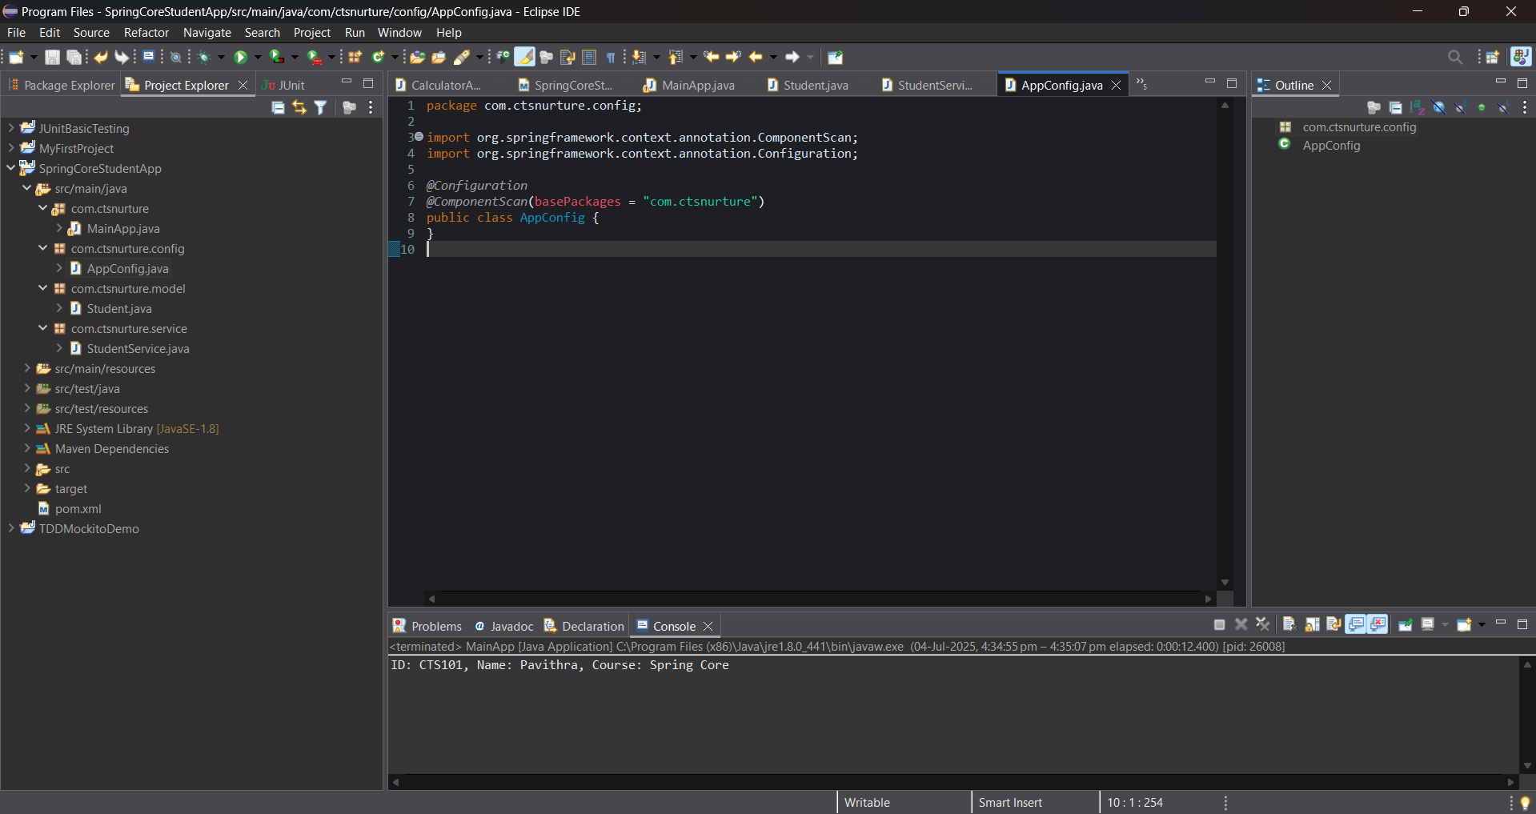

# Class: MainApp.java (inside com.ctsnurture package)

package com.ctsnurture;

import com.ctsnurture.config.AppConfig;

import com.ctsnurture.model.Student;

import com.ctsnurture.service.StudentService;

import org.springframework.context.ApplicationContext;

import org.springframework.context.annotation.AnnotationConfigApplicationContext;

public class MainApp {

public static void main(String[] args) {

ApplicationContext context = new AnnotationConfigApplicationContext(AppConfig.class);

StudentService service = context.getBean(StudentService.class);

Student student = service.registerStudent("CTS101", "Pavithra", "Spring Core");

student.showDetails();

}

}

